



**CSI4900[W]**

**Honours project 20241**

**winter 2024**

**Regional Weather Forecasting**

**Using Neural Networks**

Professors: Prof. Tet Yeap, Prof. Iluju Kiringa Date: Apr. 24th, 2024

Students:

Sattar Abdul 300156257

Osa Ikhinmwin 300211931

David Yin 300173743

**Abstract**

This project aims to advance regional weather forecasting through the application of Neural Networks, specifically Multilayer Perceptrons (MLP) and Time Delay Neural Networks (TDNN). Targeting micro-climate predictions, the study utilizes historical weather data to train models capable of accurately predicting future conditions. By implementing a rolling window approach for recursive forecasting, the project addresses the complexities of localized weather phenomena. The predictive models demonstrate promising accuracy in forecasting key weather parameters such as temperature, precipitation, air pressure, and solar radiation for some number of future steps. The project's insights serve crucial agricultural decision-making, optimizing operations such as planting and irrigation scheduling.

**Introduction**

Micro-climate prediction involves the forecasting and analysis of localized variations in weather conditions within specific, relatively small regions. Unlike broader regional or macro-climate predictions, which provide generalized weather information for large areas, micro-climate predictions focus on understanding the intricacies of weather patterns within smaller, more homogeneous areas. Research and case studies, such as those cited in references [1, 2, 3], highlight the critical importance of precise micro-climate predictions. For instance, the study referenced in [3] describes how a farmer's decision to fertilize was based on data from a distant weather station, leading to unexpected frost damage due to unaccounted local temperature drops. This example illustrates the need for accurate, localized weather forecasting.

Weather has a huge impact on farming. Getting the weather forecast right is really important because it helps farmers plan better and manage their resources. Sometimes, the usual weather forecasts do not give us enough detail about the small-scale weather changes that can make a big difference to a farmer's field. In this context, we typically rely on broad-scale Numerical Weather Prediction (NWP) models like the High-Resolution Rapid Refresh (HRRR) model, which deliver high-resolution forecasts over large areas. Our objective is to achieve acceptable prediction accuracy in comparison with the prediction accuracy of models like HRRR by applying deep learning and recursive forecasting techniques for small regions. For the purposes of this project we focus on two models MLP and TDNN to achieve our goals and evaluate which one performs better. These models can learn from past weather patterns and help us guess future weather more accurately, especially for specific areas or small regions.

**Understanding the Challenge**

The year 2020 marked a period of climatic anomalies, with many regions in Canada experiencing record-low precipitation and unprecedented high temperatures. These conditions posed significant challenges to the agricultural sector, highlighting the urgency for refined weather prediction models. With specific areas recording rainfall deficits up to 50% below the long-term average, the demand for accurate micro-climate predictions has never been more pressing. Such forecasts are not only vital for day-to-day agricultural operations but also for long-term planning and risk management amidst an ever-changing climate.

**Data Collection and Processing**

Our project began by gathering data from our main source Weather Stats Canada, specifically for Ottawa and Ottawa South stations. These records provided us with a big amount of meteorological data with a wide range of features which made our project possible.

In processing these datasets, we took several important steps to ensure its quality and usability for the purposes of this project. Firstly, since we were only interested in the warm season we only picked the stats for each year from May to November and imputed the rest. After that, we addressed the problem of missing values, which were particularly prevalent in the solar radiation measurements. To resolve this, we applied linear interpolation methods that filled these gaps, preserving the datasets’ continuity and reliability.

In the next phase, we selected the most influential features for predicting regional weather patterns that are in line with the objectives of our project. After careful consideration, we chose to focus on average hourly temperature, precipitation, air pressure, and solar radiation.

In order to effectively train our two neural networks models, we normalized the datasets using the MinMaxScaler technique. This process adjusted all our selected features to a consistent scale which is necessary to improve performance and accuracy of deep learning models. Finally, we transformed our datasets to a format suitable for supervised learning to feed into our two models as inputs.

**Methodology**

In our project, we aim to forecast daily weather parameters for a localized region over a time period starting from a given date. Specifically, our task involves predicting the four climate parameter values as model features: average hourly temperature (over 24 hours), precipitation, air pressure measured at station, and solar radiation. These predictions are specific to a particular location, which are made following model training using the historical data available for the target location. Using two modified model types, derived from Multi-Layer Perceptron (MLP) and Time-Delayed Neural Network (TDNN) implementations, we train to leverage the model’s attention and correctness on the prediction patterns of the available network.

The historical dataset consists of past climate parameter values measured daily for station throughout the time period. For our training set, we select the values for the time range 2013-2022. We further limit the data to the month range from May to November (i.e., select the data from the dates May 1st to November 30th) to emphasize data relevance in agricultural applications.

Model testing and comparison is performed in the same month range of 2023 for the corresponding weather station. Prediction is performed sequentially from recursive forecasting, relying on the location’s historical data and a time window of set size for the target station immediately preceding the prediction period.

Historically, climate forecasts for a particular location are performed through the synthesis of observational analysis and differential systems that rely on current and historical measurements. Our approach focuses on giving predictions based on historical trends and using a small time frame of recent data.

**Model Structure**

The structures for the models we have used are depicted. The central goal is to develop a model capable of extrapolating the weather patterns of a location given its historical weather values. The model uses this knowledge to generate a transformation function that may sequentially output forecasts of the model features that immediately follow the given initial window of values for the location in question.

The recursive forecasting procedure is depicted in figure 1:

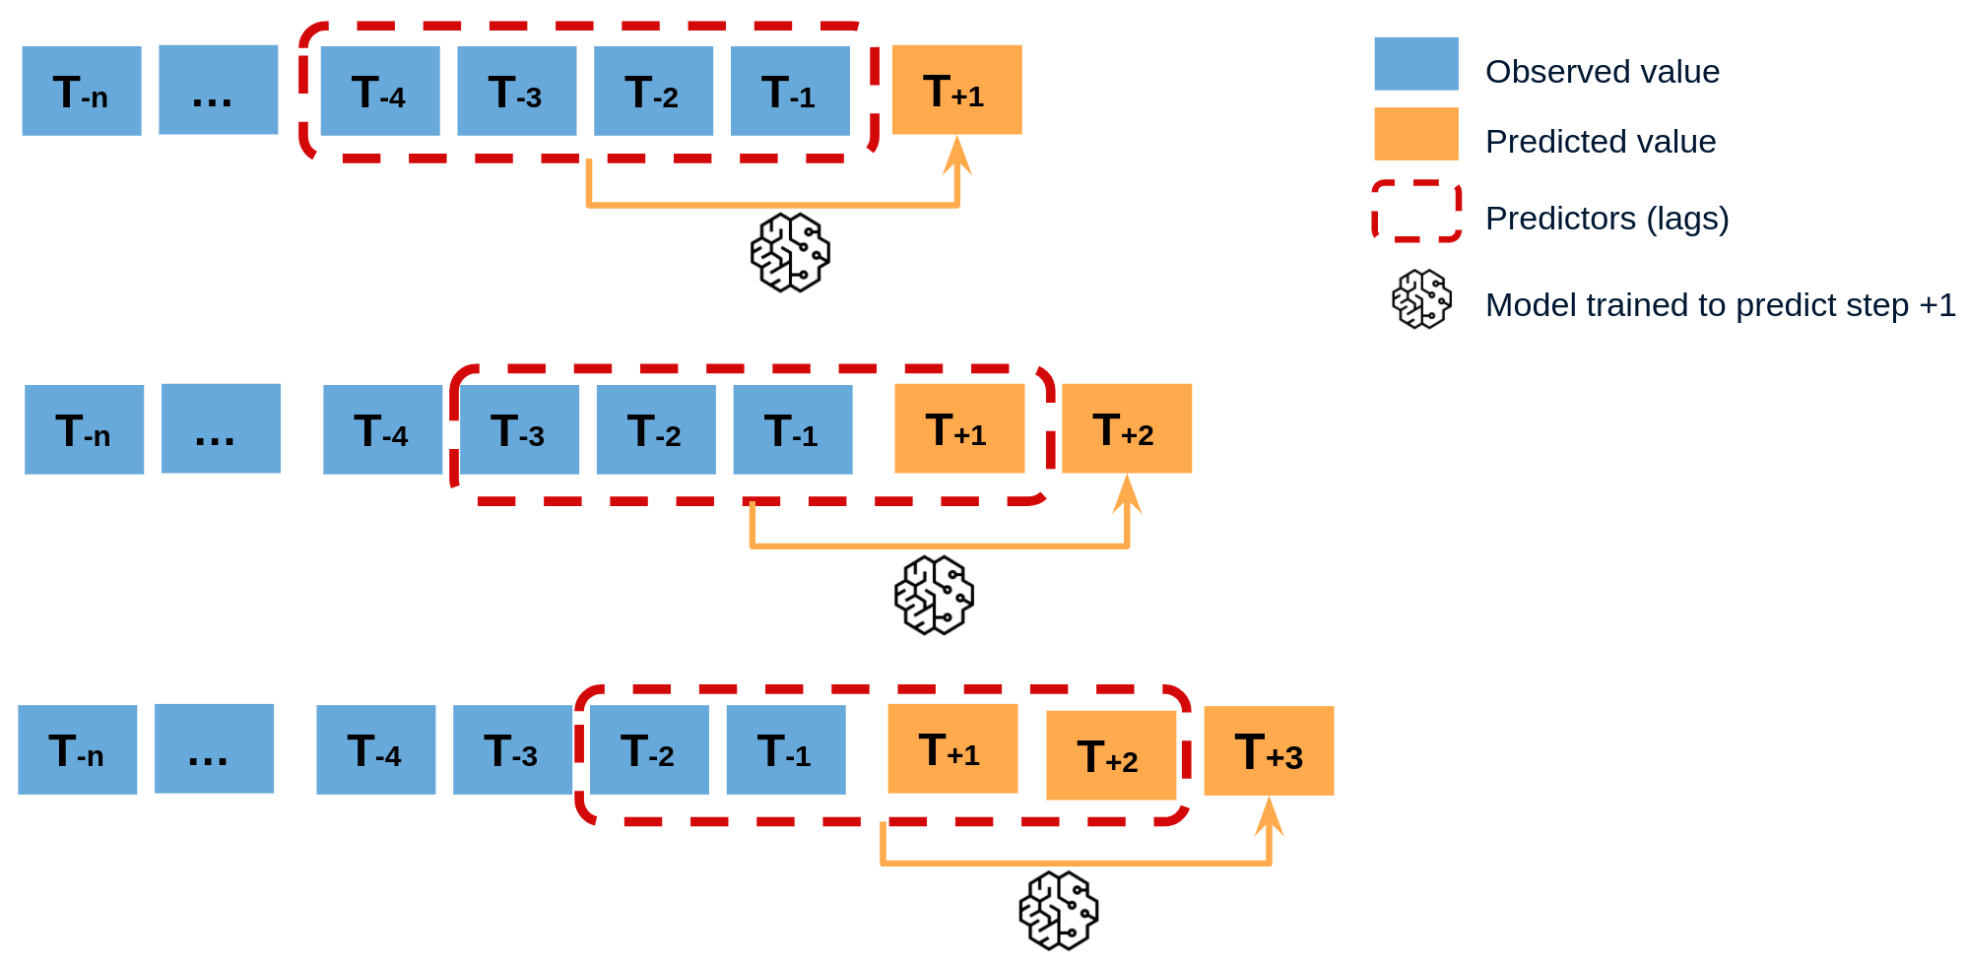*Figure 1*: recursive forecasting process. Source: https://skforecast.org/0.9.1/user_guides/autoregresive-forecaster

To perform recursive forecasting using the window, the newly predicted value is added to the end of the window. The oldest value (from the left) is then removed, and the model uses the newly formed window to predict the value for the next time step.

**Model Development**

The MLP model designed for our time-series forecasting of weather data consists of a sequential architecture with three linear layers. The input layer receives the data, which is then passed through two hidden layers of 128 and 64 neurons, respectively, with ReLU activation functions to introduce non-linearity between the layers. The final output layer consists of units equal to the number of features being predicted, which in this case is four: average hourly temperature, precipitation, solar radiation, and average hourly pressure station. This architecture was chosen for its simplicity among non-linear activations as well as its fast training speed. It is held as a baseline performance for comparison to the more advanced TDNN implementation.

The Time Delay Neural Network (TDNN) implemented for weather forecasting leverages convolutional layers tailored for temporal data. The architecture is designed to process sequences effectively by better capturing temporal dependencies. The key components of the TDNN architecture include convolution layers, ReLU activation, and dropout functions. Given the sequential nature of weather data, the TDNN's ability to extract and learn from time-localized patterns makes it effective based on the assumption that past weather conditions may significantly influence future outcomes.

For both models, training involved the forward pass, loss computation using Mean Squared Error (MSE), backpropagation to update the weights, and an optimization step using Adam optimizer. This process was iterated over multiple epochs (50) to minimize the loss and lead to convergence.

As mentioned, the data was first normalized before training using a MinMaxScaler to ensure that the neural network model received input features in a scaled range (from 0 to 1) to prevent any one feature from dominating the model’s learning process due to scale differences from the input features.

**Results and Discussion**

Figures 2 to 5 depict the prediction outcomes for MLP for the prediction period May to November, 2023, graphed against the actual values measured at the weather station for the corresponding period. Figures 6 to 9 depict the above outcomes for TDNN. Tables 1 and 2 demonstrate the Mean Average Error (MAE) and Root Mean Square Error (RMSE) value comparisons between the two models for the prediction periods 14 days and 7 months (May to November, 2023).

Despite attempts to modify model behaviour, predictions for solar radiation are particularly poor for both models for both MAE and RMSE measurements. The actual values rapidly fluctuate in great amplitude and have little correlation and similarity to the other features as well as to (solar radiation) data from previous years in the same location.

The predictions from the MLP model correlate poorly with the pattern of the actual values. Increasing the window size for the MLP model (from 3 to 30 days) yielded poor results for temperature predictions, meaning that the model has failed to capture the desired weather pattern. This is significantly noticeable in figure 5. Moreover, the predictions converge rapidly onto a continuous curve and do not resemble the fluctuation pattern of the actual data. Error accumulation is not corrected overtime, resulting in higher MAE and RMSE values for longer prediction periods when comparing between the predictions for the next 14 days, as opposed to the next 210 days.

The predictions for the TDNN model for two window sizes are shown. Prediction for Solar Radiation closely follows the amplitude mean. An increase in window size yielded significantly better results for temperature predictions.

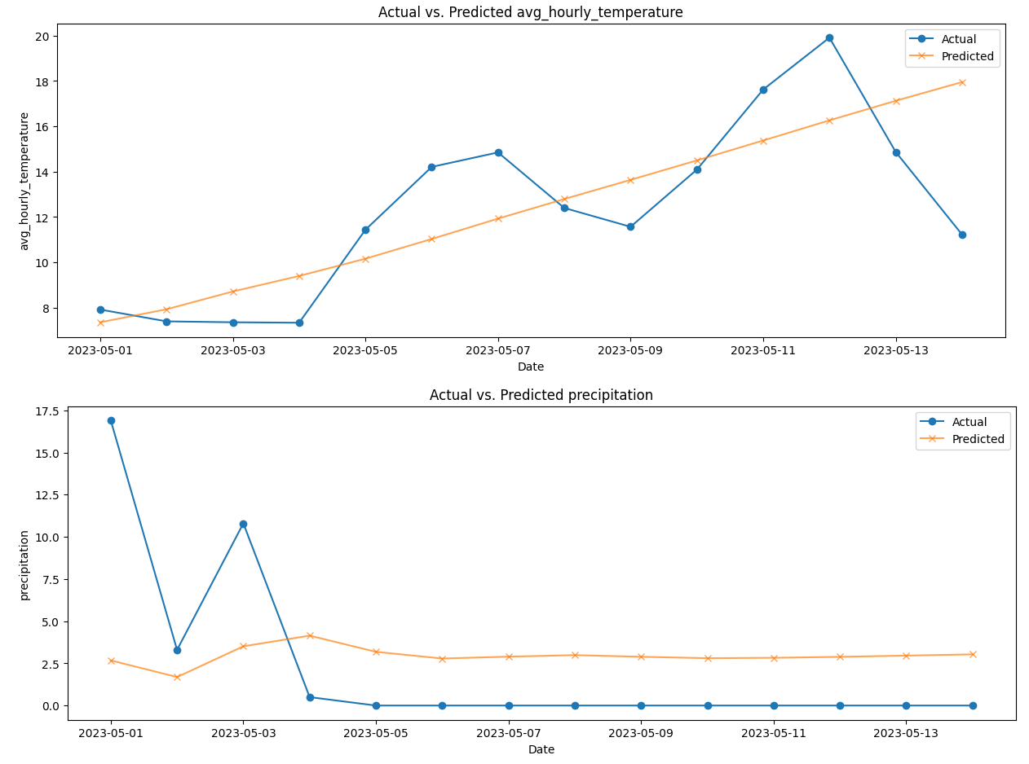

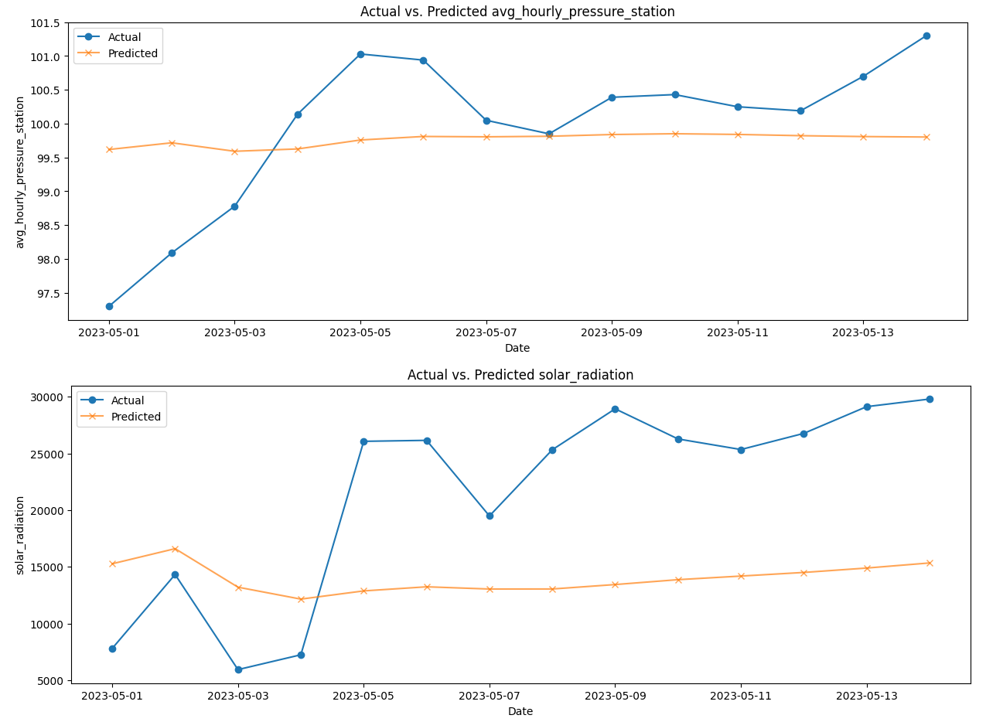

Figure 2: Model 1: MLP model feature predictions vs. actual values for 14 day prediction period for Ottawa station, window size = 3 days.

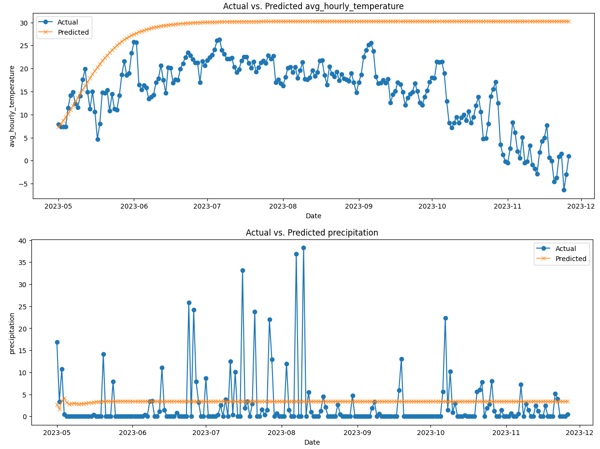

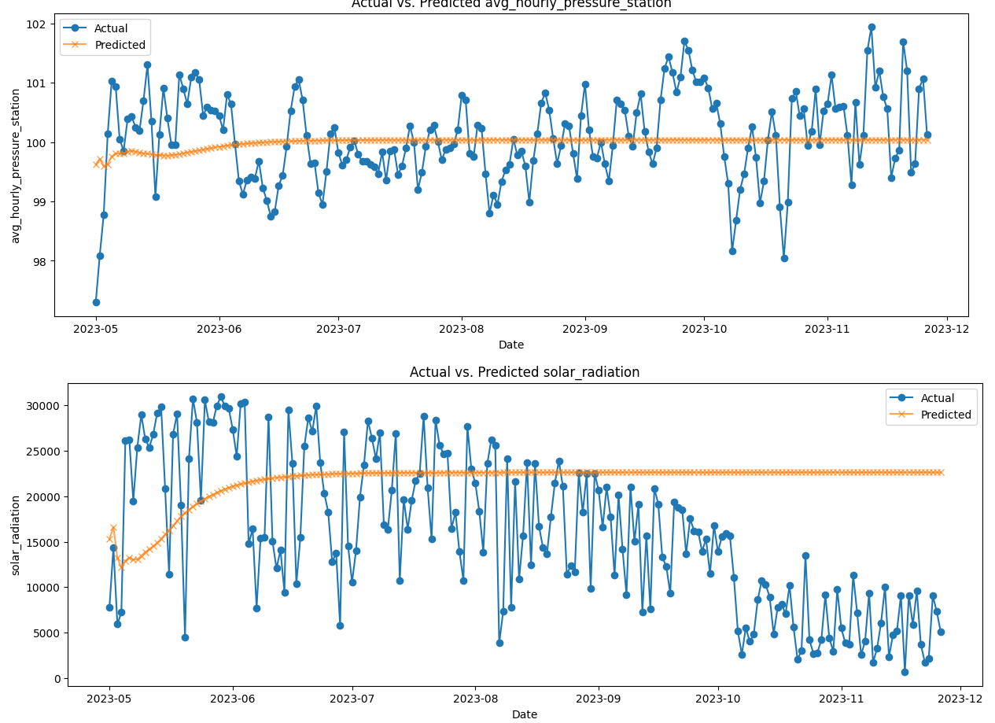

Figure 3: Model 1: MLP model feature predictions vs. actual values for 210 day prediction period for Ottawa station, window size = 3 days.

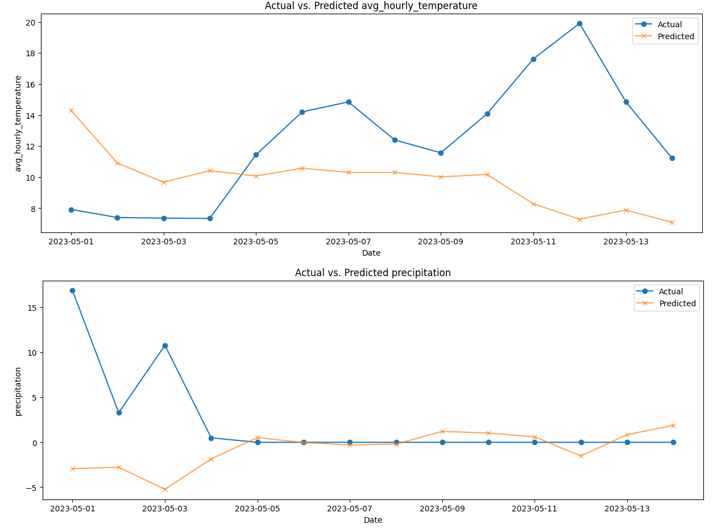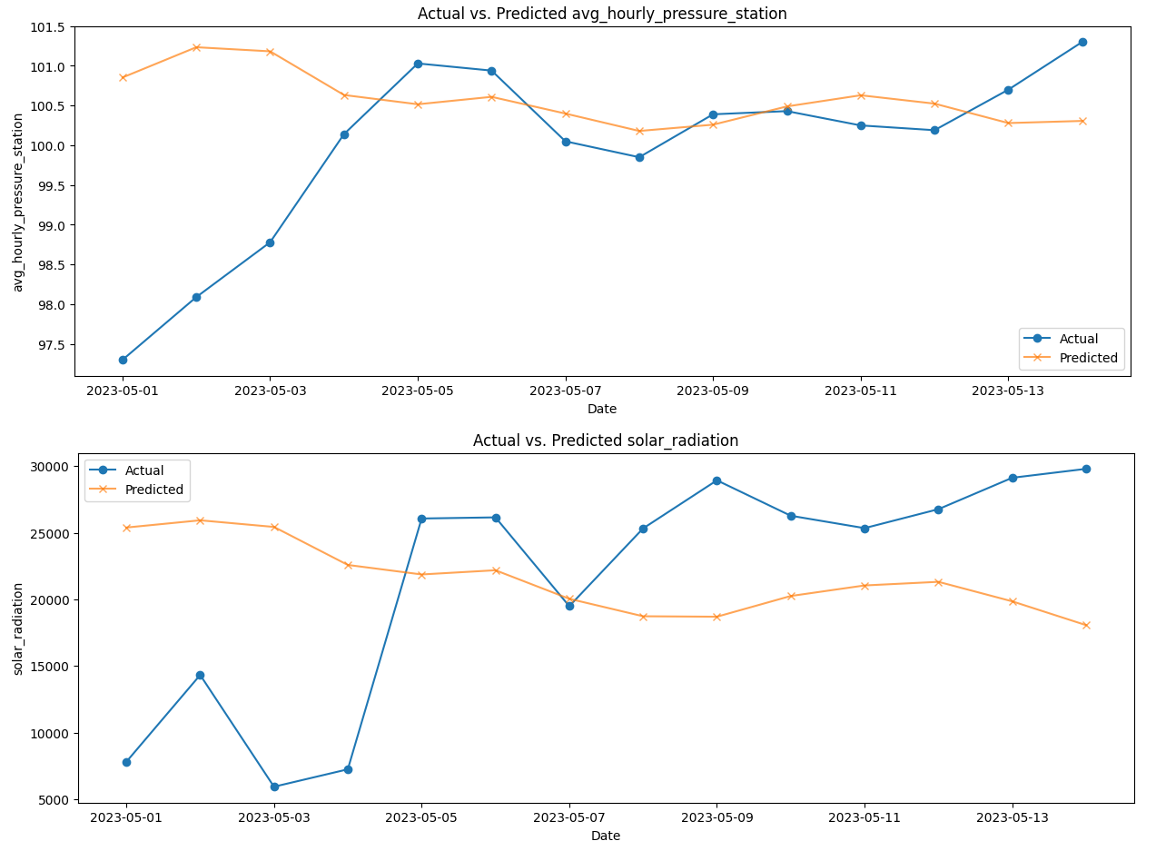

Figure 4: Model 1: MLP model feature predictions vs. actual values for 14 day prediction period for Ottawa station, window size = 30 days.

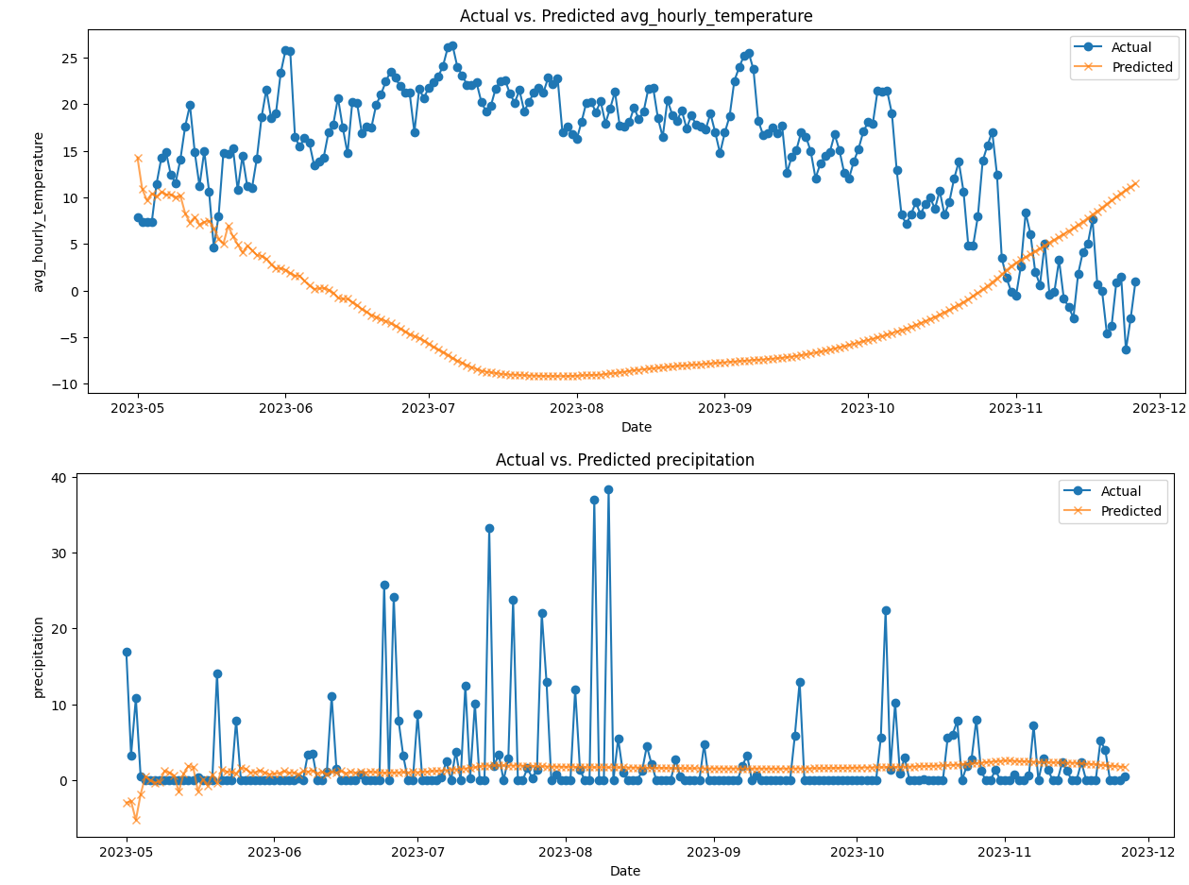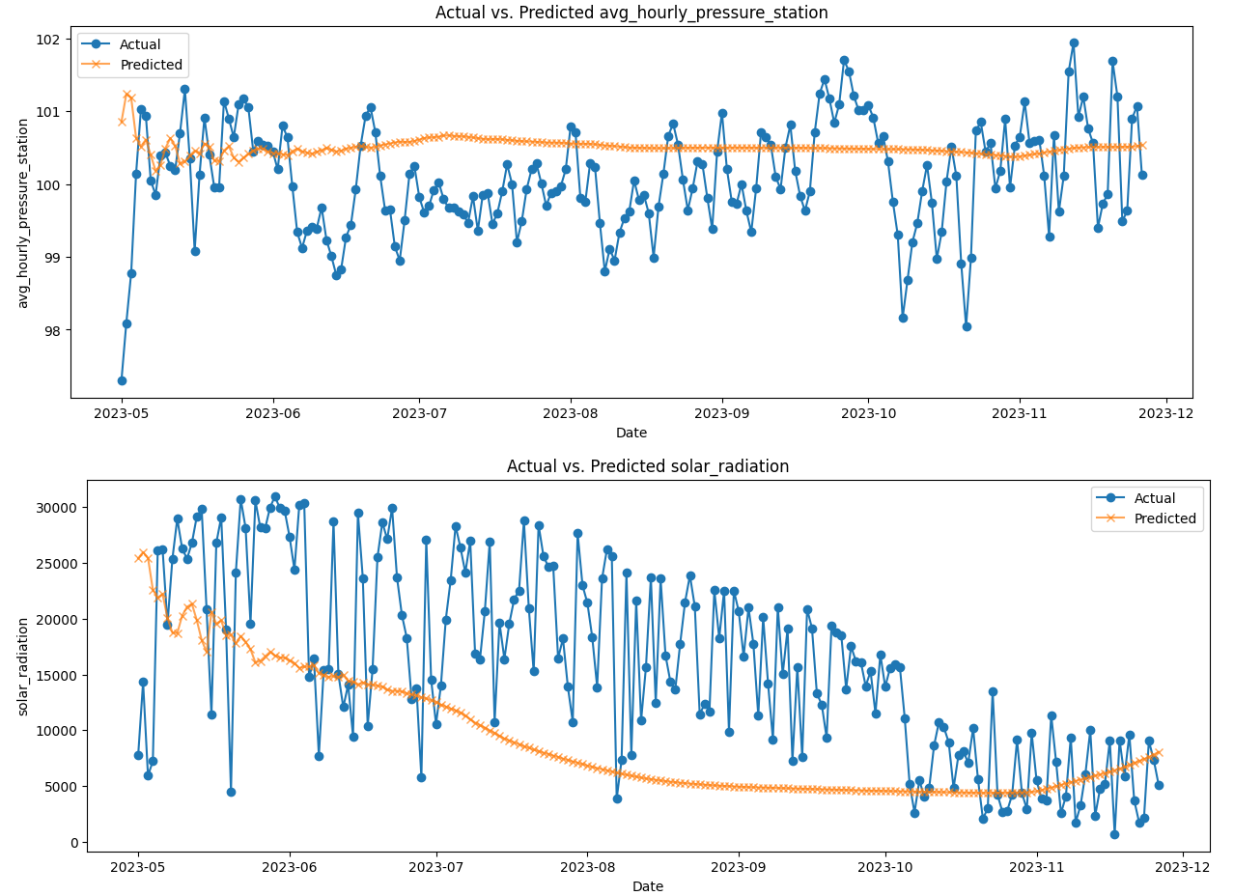

Figure 5: Model 1: MLP model feature predictions vs. actual values for 210 day prediction period for Ottawa station, window size = 30 days.

For the TDNN model figures, the x-axis represents the number of days offset from the last day of the initial window provided. The data for the initial window beginning from the first day of May. Two window sizes, 3 days and 30 days, are tested for both models.

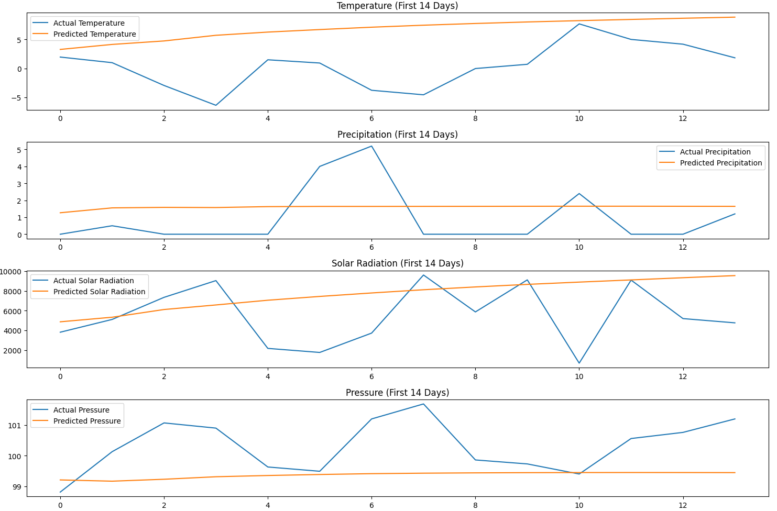

Figure 6: Model 2: TDNN model feature predictions vs. actual values for 14 day prediction period for Ottawa station, 3 day window size.

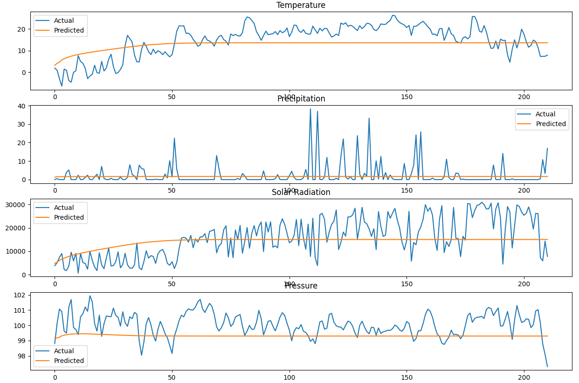

Figure 7: Model 2: TDNN model feature predictions vs. actual values for 210 day prediction period for Ottawa station, 3 day window size.

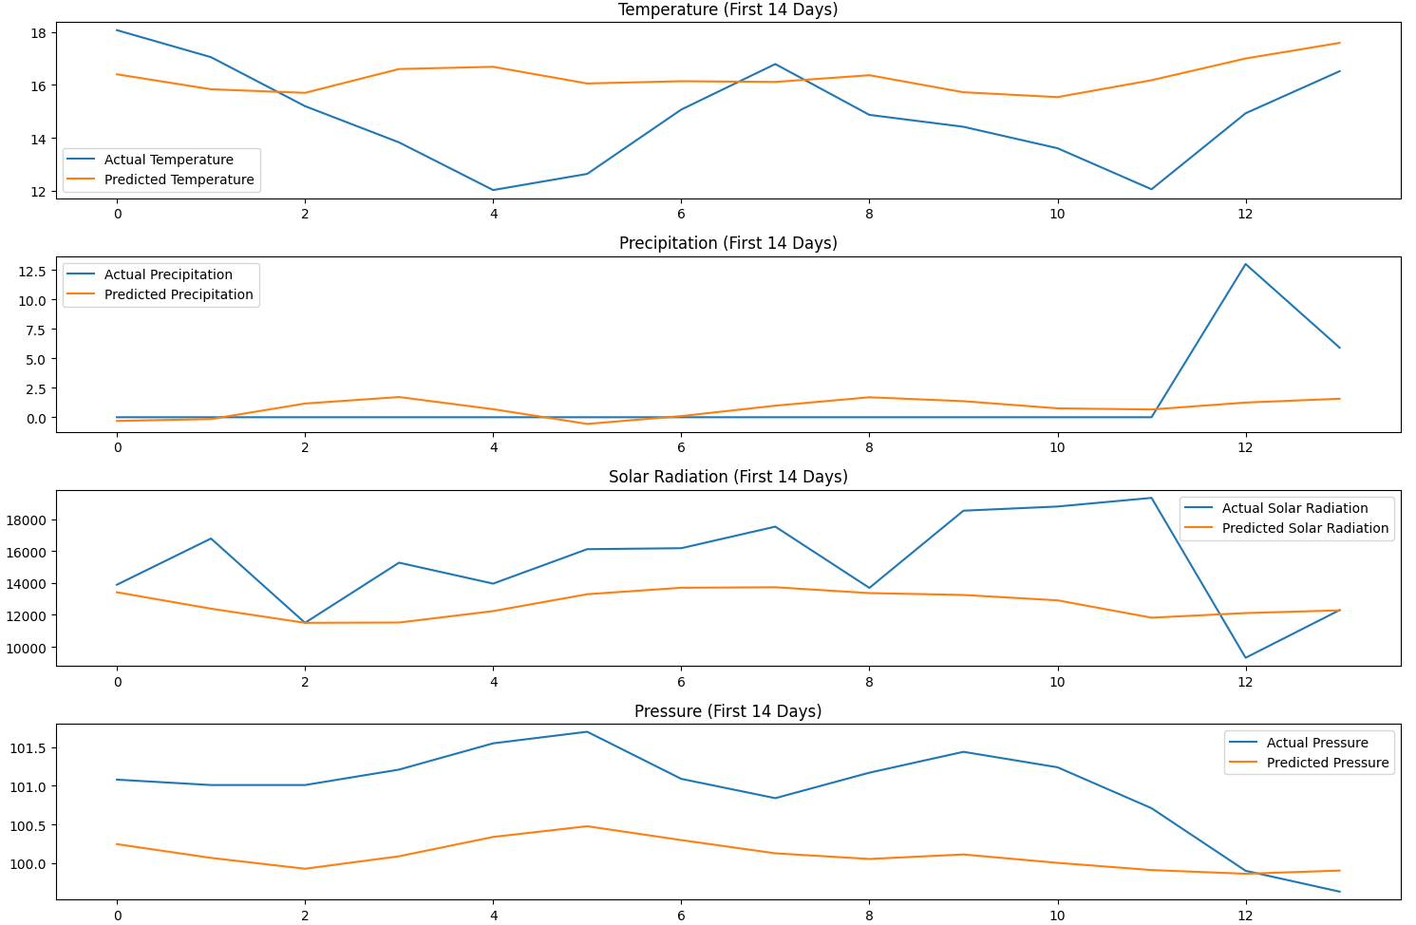

Figure 8: Model 2: TDNN model feature predictions vs. actual values for 14 day prediction period for Ottawa station, 30 day window size.

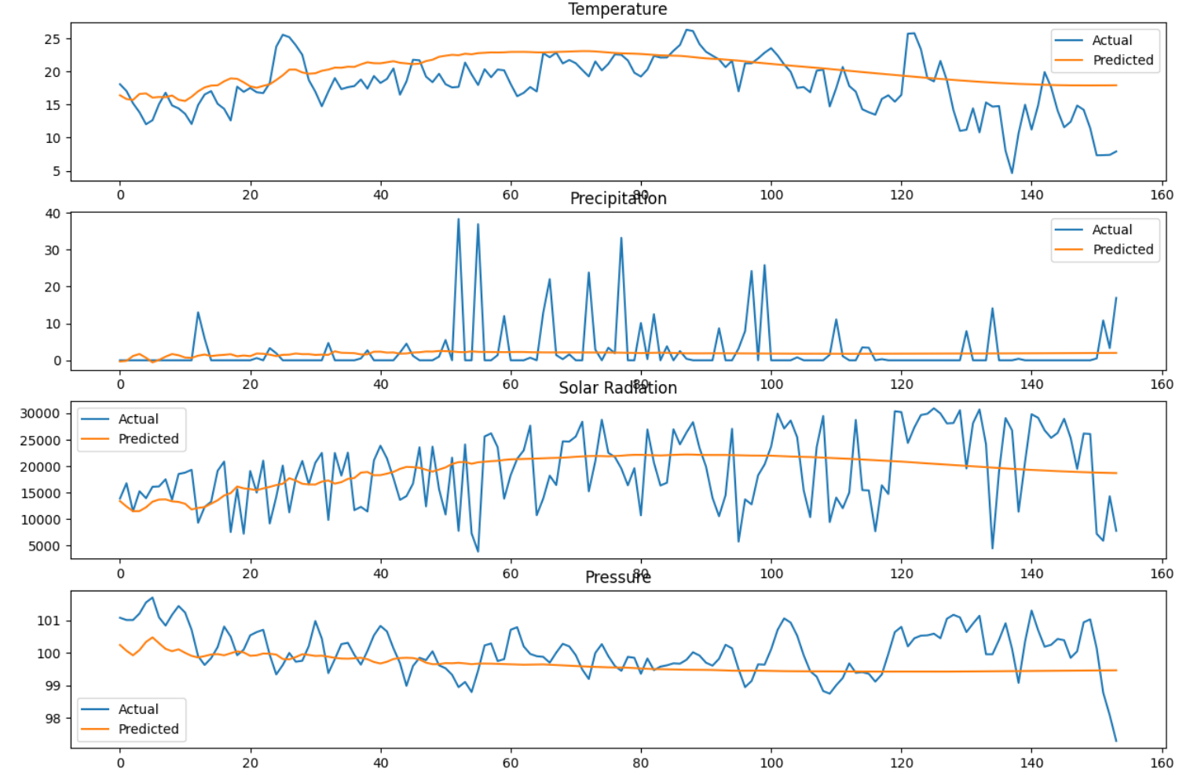

Figure 9: Model 2: TDNN model features predictions vs. actual values for 210 day prediction period for Ottawa station, 30 day window size.

| Model | | MAE | | RMSE | |
| --- | --- | --- | --- | --- | --- |
| 14 days | 210 days | 14 days | 210 days |
| Model 1: MLP | Avg. Hourly Temperature | 2.122 | 8.130 | 2.692 | 10.822 |
| Precipitation | 4,127 | 3.96 | 4.796 | 6.14 |
| Station Pressure | 0.704 | 0.586 | 0.944 | 0.728 |
| Solar Radiation | 8518.94 | 9400.27 | 9922.68 | 11126.08 |
| Model 2: TDNN | Avg. Hourly Temperature | 6.300 | 5.365 | 7.221 | 6.238 |
| Precipitation | 1.604 | 3.104 | 1.751 | 6.135 |
| Station Pressure | 1.011 | 0.881 | 1.245 | 1.056 |
| Solar Radiation | 2947.26 | 6339.92 | 3759.49 | 7705.34 |

Table 1: MAE and RMSE for MLP and TDNN models. Window size = 3, Prediction period = 14 days, 210 days.

| Model | | MAE | | RMSE | |
| --- | --- | --- | --- | --- | --- |
| 14 days | 210 days | 14 days | 210 days |
| Model 1: MLP | Avg. Hourly Temperature | 24.535 | 18.706 | 26.019 | 21.057 |
| Precipitation | 3.323 | 3.120 | 5.525 | 6.322 |
| Station Pressure | 0.752 | 0.703 | 0.856 | 0.882 |
| Solar Radiation | 15030.75 | 8315.50 | 16630.92 | 10124.08 |
| Model 2: TDNN | Avg. Hourly Temperature | 1.998 | 3.119 | 2.348 | 4.006 |
| Precipitation | 1.874 | 3.443 | 3.472 | 6.750 |
| Station Pressure | 0.909 | 0.615 | 0.978 | 0.779 |
| Solar Radiation | 2941.94 | 5701.26 | 3696.27 | 6737.27 |

Table 2: MAE and RMSE for MLP and TDNN models. Window size = 30, Prediction period =14 days, 210 days.

Note that for the TDNN models, an increased window size from 3 to 30 resulted in significantly lower MAE and RMSE values. For MLP, this was not the case for the temperature attribute. The prediction results severely deviate from the actual values when using a 30 day prediction window.

**Challenges**

Throughout this project, we encountered several challenges that tested the limits of our models and our approach to solving the problem at hand. The first challenge we faced was data quality and completeness. Some features in the datasets contained missing values. fixing this issue involved carefully filling in missing values without skewing the dataset with errors.

Model selection and optimization at the beginning was another challenge. We had to make sure to select the right deep learning models to achieve the objectives of our project. The architecture and parameters of the model needed to be sophisticated enough to understand and learn complex weather patterns without becoming too complicated that the model would overfit the data or become too difficult to train.

Accuracy in longer term predictions was another big challenge, especially given the volatile and unpredictable nature of weather forecasts. In deep learning models minor errors can lead to bigger errors quickly and therefore to unreliable results. At each turn, we had to make sure the models do not overfit or underfit using different techniques in order to obtain the best results possible. Lastly, the adaptability of our model to real-world conditions was another test. The best measure of success for any weather prediction model lies in its performance against real-world data and its ability to respond to live weather patterns, rather than relying solely on historical data. Our models needed to be flexible and responsive enough to reflect actual meteorological conditions accurately.

**Conclusion and Future Work**

Our study has demonstrated the capabilities and limitations of using neural networks for micro-climate predictions. The Multilayer Perceptron (MLP) model showed rapid performance in regression tasks but faced limitations when the forecasting window was increased, indicating a potential trade-off between speed and long-range prediction accuracy. On the other hand, the Time Delay Neural Network (TDNN) excelled in capturing the intricate patterns of time-series data. The adaptability of the TDNN was evident as it showed improved performance with an increased window size, affirming its suitability for capturing and forecasting complex weather trends over time. Both models yielded accurate short-term predictions for temperature and precipitation, highlighting their applicability in critical forecasting scenarios. Overall, the results underline an excellent potential for improvement in micro-climate forecasting models.

**Future Work**

Looking ahead, the pathway for advancing these forecasting models is numerous. Future research should consider refining the recursive forecasting windows' size and starting points in both the Multilayer Perceptrons (MLP) and Time Delay Neural Networks (TDNN) models to enhance their adaptability and improve forecast accuracy across various temporal scopes.

Additionally, optimizing the feature selection process could streamline the models further, focusing on the most impactful data for more accurate predictions. The exploration of more complex neural network architectures, such as Recurrent Neural Networks (RNNs) and Long Short-Term Memory (LSTM) networks, is recommended to uncover deeper insights and achieve higher accuracy, particularly for long-term predictions.

Implementing ensemble methods that combine forecasts from multiple models may also yield more robust predictions by capturing a broader range of patterns and reducing individual model biases.

Finally, enhancing the scalability of these models to handle larger datasets and integrating them into real-world testing environments is essential. This step will help validate their effectiveness and adaptability in operational settings, aiming to integrate these enhanced forecasting models into real-world agricultural planning and management systems. This comprehensive approach is not only expected to refine the forecasting models but also to extend their practical utility, potentially transforming how micro-climate forecasting supports agricultural decision-making and operations.

**References**

[1] Oladayo S Ajani, Member Joy Usigbe, Esther Aboyeji, Daniel Dooyum Uyeh, Yushin Ha,

Tusan Park, and Rammohan Mallipeddi. Greenhouse micro-climate prediction based on fixed

sensor placements: A machine learning approach. Mathematics, 11(14):3052, 2023.

[2] Anastasia Eleftheriou, Kostas Kouvaris, Petros Karvelis, and Chrysostomos Stylios. Micro

climate prediction utilizing machine learning approaches. In 2018 IEEE International Workshop

on Metrology for the Sea; Learning to Measure Sea Health Parameters (MetroSea), pages

197–200. IEEE, 2018.

[3] Peeyush Kumar, Ranveer Chandra, Chetan Bansal, Shivkumar Kalyanaraman, Tanuja Ganu,

and Michael Grant. Micro-climate prediction-multi scale encoder-decoder based deep learning

framework. In Proceedings of the 27th ACM SIGKDD Conference on Knowledge Discovery &

Data Mining, pages 3128–3138, 2021.

[4] I. Deznabi, P. Kumar, and M. Fiterau, "Zero-shot microclimate prediction with deep learning," in *Proc. Manning College of Information and Computer Sciences Conference*, Amherst, MA, USA, 2023.

**Appendices**

